# M1C2 UI/UX Assignment

*During this module, you have been introduced to UI/UX Development. UI/UX is used to make sure that applications are accessible and easily understood. You have been introduced to a variety of tools like sitemaps, wireframes, and color schemes, that help developers when they are working on user interfaces and user experiences. You will use a variety of those tools during this assignment. If you can’t remember how to build what is asked, refer back to the videos that explain each concept and try looking up examples. Please complete the following assignment and reach out on the Support App to have a mentor review your work. If you have any questions or need any help, please reach out so we can help you! This assignment must be completed to pass this section of the coursework.*

**Task One:** Referencing this image, create a low-fidelity wireframe.

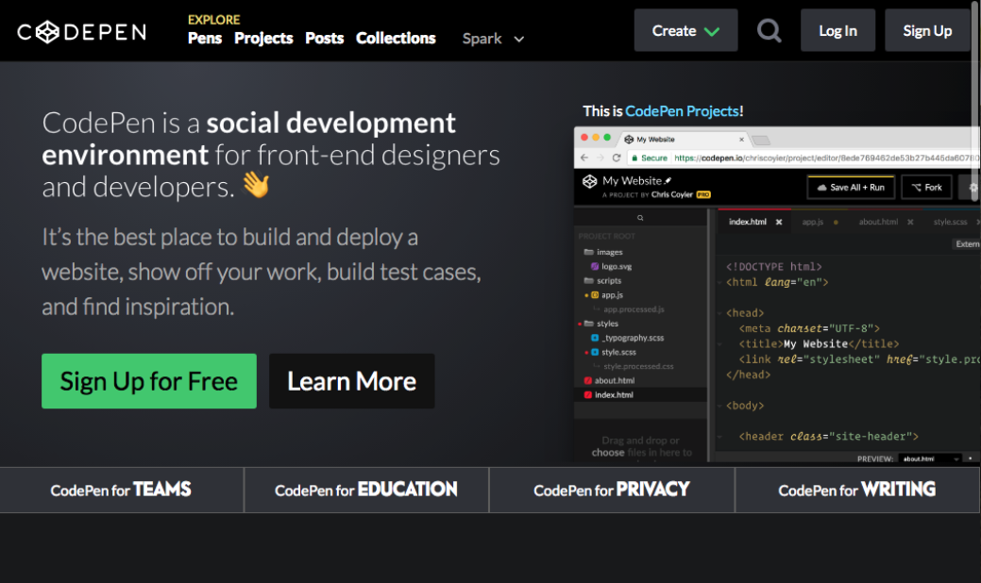

Answer: Made with invision

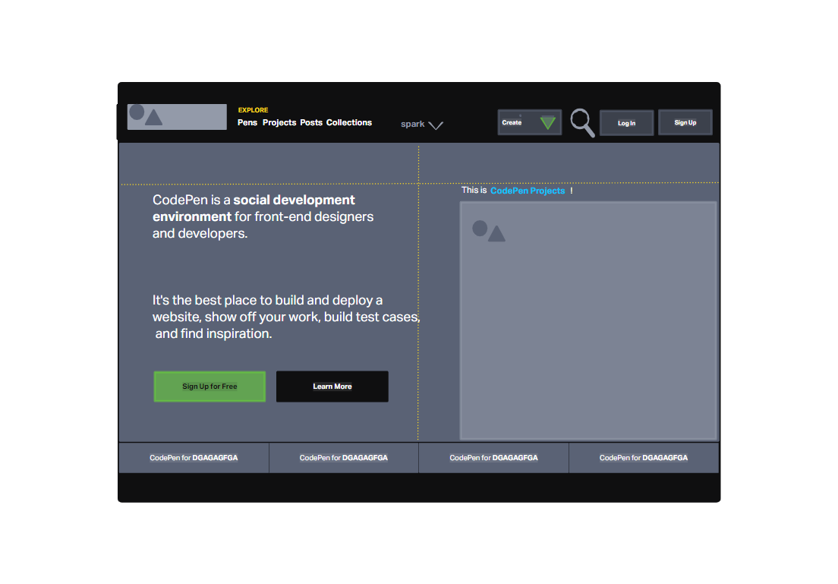

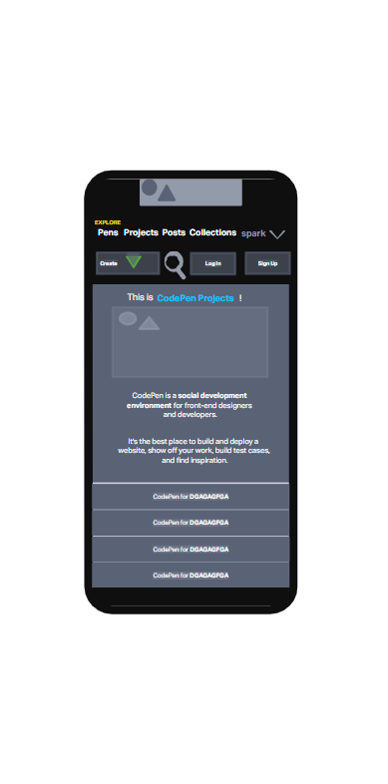

**Task Two:** Use one of the following websites and the inspect tool to identify 2-3 colors used repeatedly as part of the site’s color scheme. Remember that different shades of gray and black can be included as a color.

* <https://timmyomahony.com/>
* <https://sebkay.com/>
* <https://jonny.me/>
* <https://jacekjeznach.com/>

Answer

* <https://sebkay.com/>

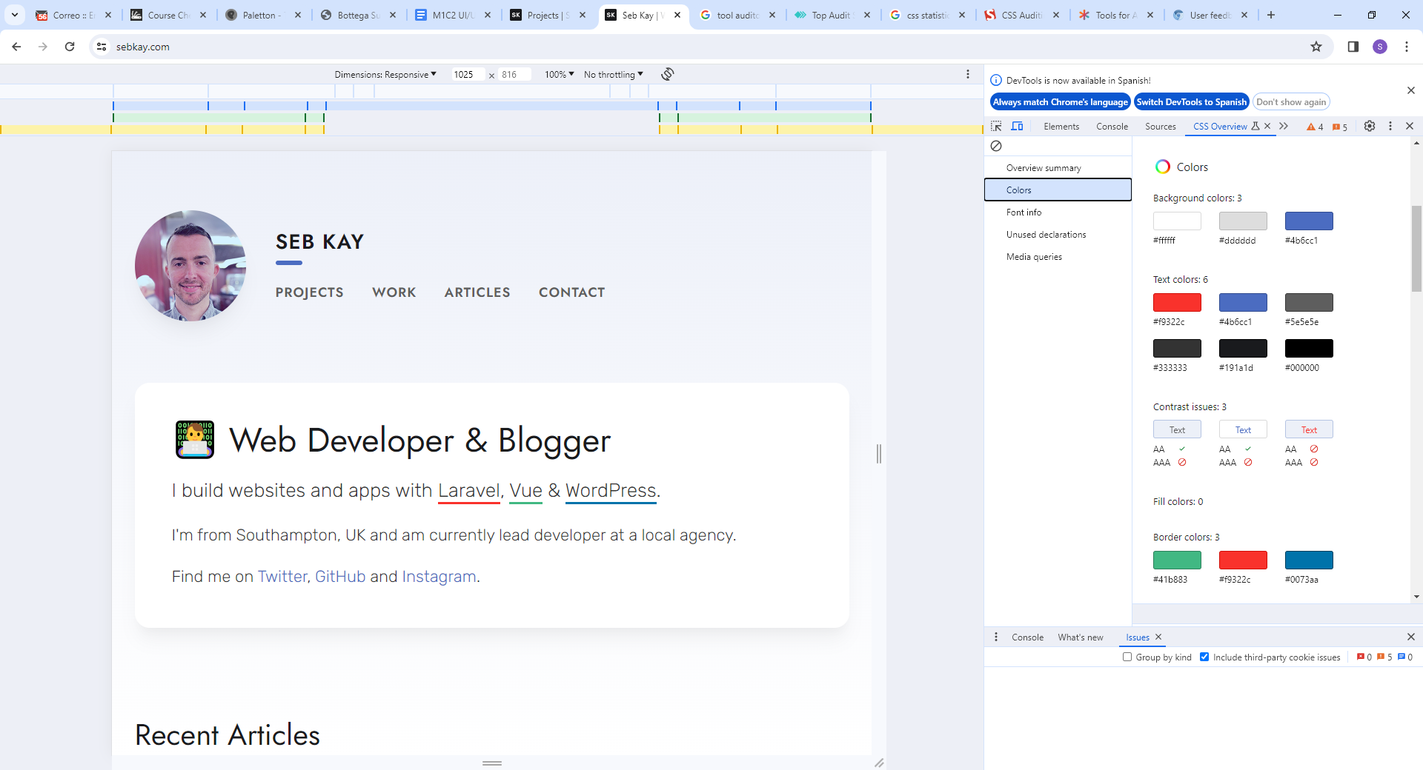

**Task Three:** Create a user story by referencing one of these websites

* [Twitter](https://twitter.com/home?lang=en)
* Youtube <https://www.youtube.com/>
* Facebook <https://www.facebook.com/>
* Google <https://www.google.com/>

Answer

https://www.youtube.com/

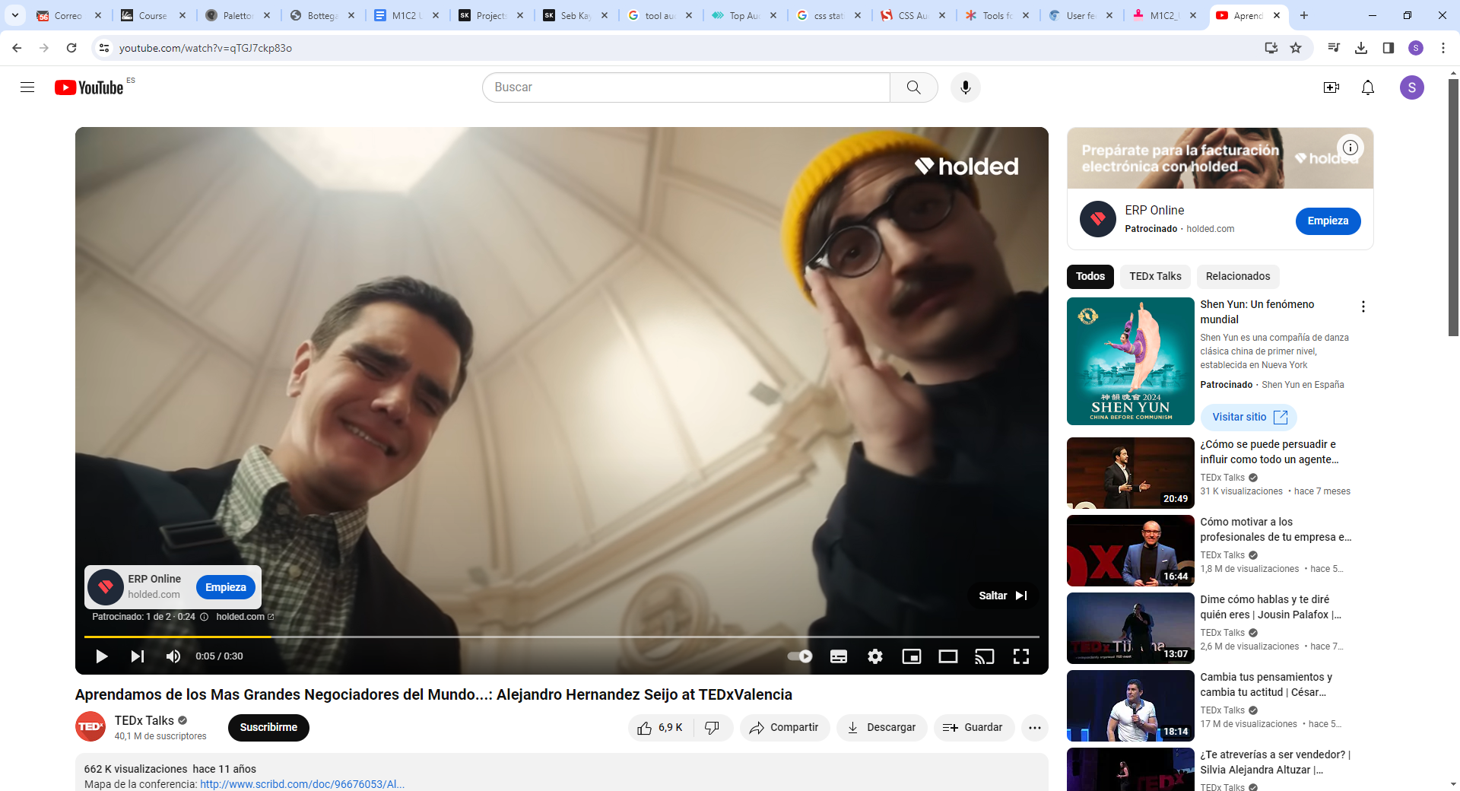

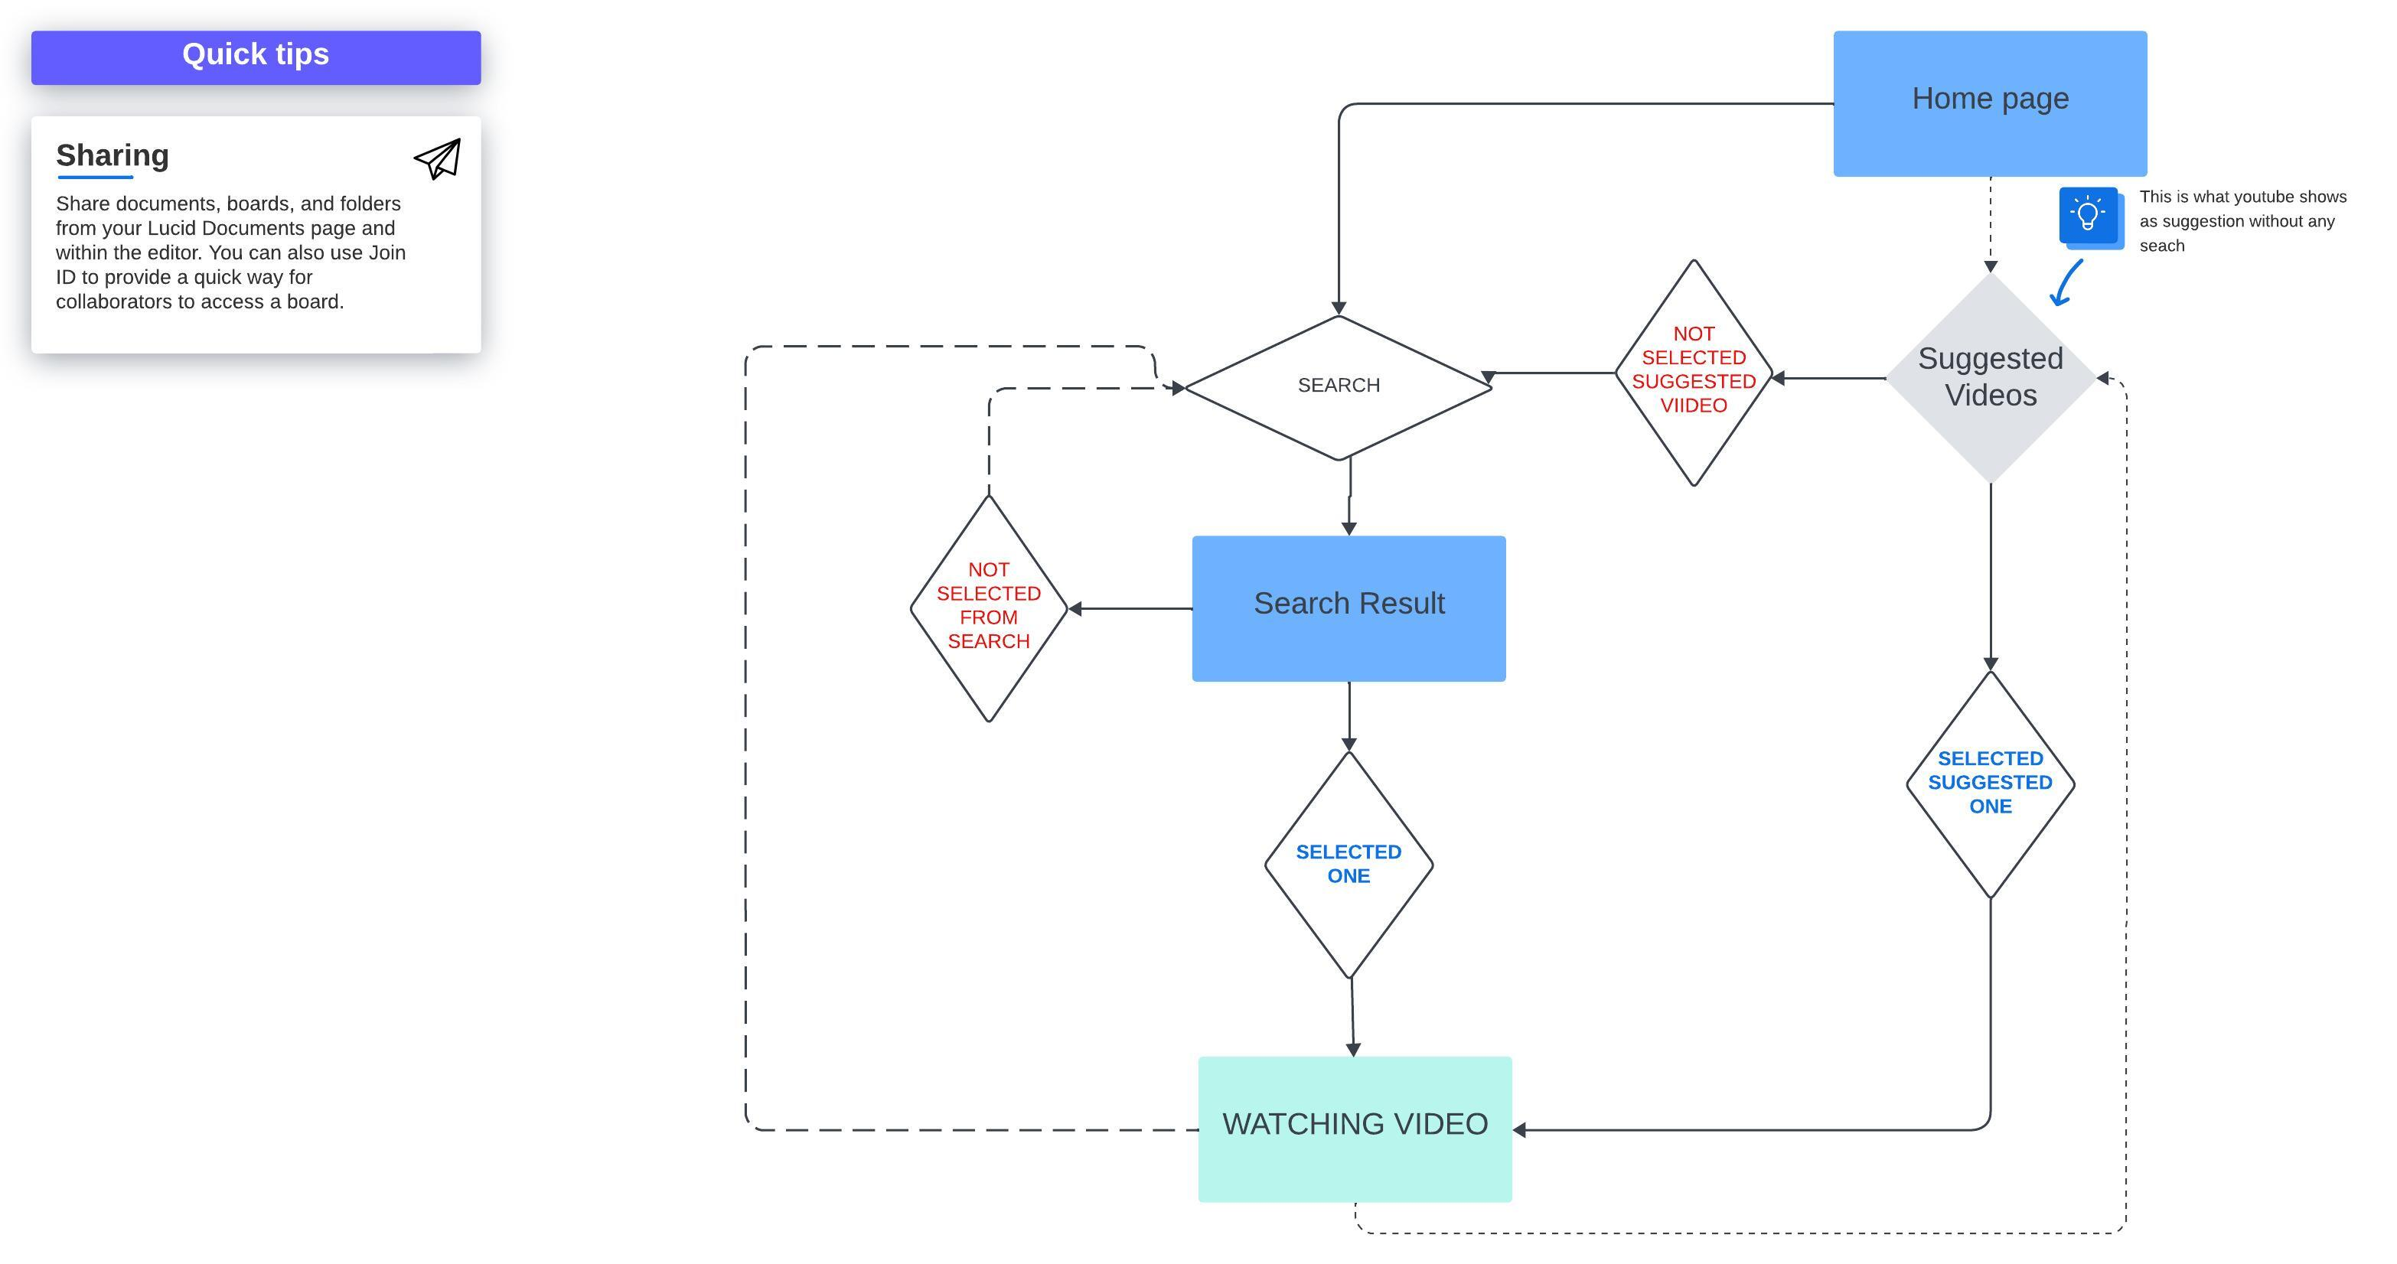

**Task Four:** Identify the prime objective of Facebook, Twitter, Google, and Youtube.

Answer

To start with it must be said that four of them are very often used in mobile devices. Therefore, they have to be really friendly in those devices sizes.

All those application users are expecting to be fast, easy to read or to watch and nice.

All of them need to catch the user’s feedback.

|  |  |  |
| --- | --- | --- |
|  |  | |
| **Stated Mission** | * Facebook's stated mission is "to give people the power to share and make the world more open and connected." On its site, Facebook explains that it believes that increased connection between people through their site will lead to better understanding between disparate groups. * Facebook is designed to be free for its users; it should give them control of their information and who can access it, according to the company's statement of principles. | |
| **Prime Objective** | | As they describe as mission on it’s site, Facebook explains that it believes that increased connection between people through their site will lead to better understanding between disparate groups. the **primer objective** is to connect people.  What is needed as interface is far more complex than twitter since the text can be longer, the post can have photos or videos, etc..  Anyway what is needed is to be clear in the way we write and show our post, the way we read other’s posts and we interact with them. |

|  |  | |
| --- | --- | --- |
| **Stated Mission** | * Twitter is an American microblogging and social networking service. * Twitter's mission is to give everyone the power to create and share ideas and information instantly without barriers. | |
| **Prime Objective** | | Although is really simple the interface that it used it is enough to be clear what we have to say, that has to be sort, quick and instantly.  he **primer objective** is Cleariness and agility telling and sharing ideas and catching the others feedback in order to generate more interactions. |

|  |  | |
| --- | --- | --- |
| **Stated Mission** | What started being a search browser it has end up being one of the most productive enterprises. What they declare as their commitments are the following ones:  - Protecting users  - Building belonging  - Expanding opportunity  - Responding to crises  - Advancing sustainability | |
| **Prime Objective** | | But if we focus our analysis on the original searcher, the **primer objective** would be to give the user a good tool to do any search and offer them in a clear and structured way allowing the user to establish options to select filters.  It must use search algorithms to make user experience better. |

|  |  | |
| --- | --- | --- |
| **Stated Mission** | Our mission is to give everyone a voice and show them the world. We believe that everyone deserves to have a voice, and that the world is a better place when we listen, share and build community through our stories. | |
| **Prime Objective** | | the **primer objective** is to tell the story.  The story is to be build through videos and presentations. Everyone can watch or upload videos absolutely free. The interface has to be clear and centering the attention in the video.  It must use search algorithms to make user experience better. |
|  | |  |